**ECE-3502 IoT Domain Analyst LAB(L9+L10)**

**Name: Alpanshu Kataria**

**Reg. No.: 18BCE1267**

**Faculty: Maheshwari R**

Lab 6

**Task:**

Ex1: Home automation using Http protocol and Thingsboard.

Ex 2:Plant monitoring system using MQTT protocol and Thingsboard

**Ex1 Flow:**

**Home automation using Http protocol**

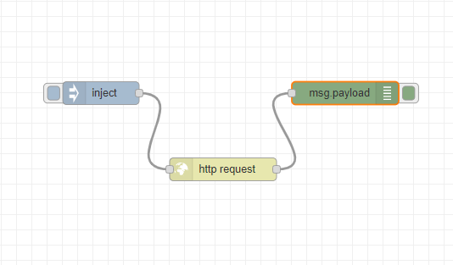

**Ex1 Node:**

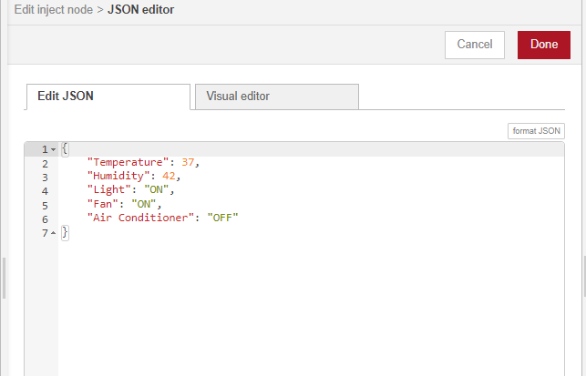

**Ex1 Dashboard:**

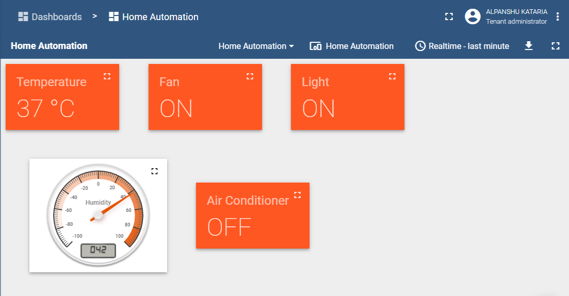

**Ex2 Flow:**

**Plant monitoring system using MQTT:**

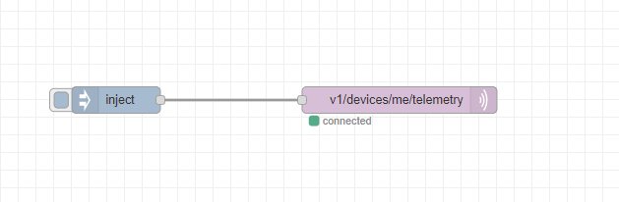

**Ex2 Nodes:**



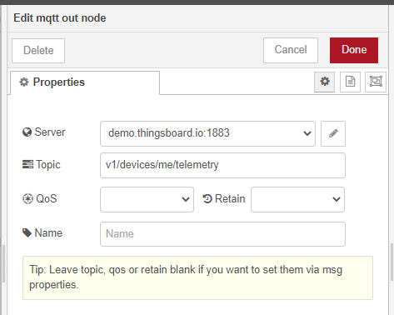

**Ex2 Dashboard:**

